MA FA exhibition space planning pro forma
Answering these questions as clearly as possible will help us allocate show spaces. We will do our best to provide you with what you need, but we cannot guarantee it, as the needs of the entire group will have to be considered when spaces are allocated.
Please note that any construction of walls or partitions will have to be agreed by your pathway leader. There will be limited technical help during the installation of the show, so your plans should not rely on help from technical staff.
Deadline for the first draft: 8th May 2025
Please upload this from to onedrive link here MA Print show proposals

Name: Jackie Smith
Course: MA Print
What do you intend to exhibit?
Please be as specific as you can, for example: how many pieces? What is the size of the proposed work/s?
• Include images and clear visualisations (use a drawing, google sketch up or diagram) of our work here. You can also use Photoshop or scan a drawing or use an image of previous similar work so we know what your work looks like and its dimensions.
Use the space provided here for images of your work:
Below is a sketched-out proposal for my exhibition (Photo 1). The exhibition will showcase my research into embodied landscape and experience, memory and touch. I would prefer an end area with space to walk around the exhibits to have an immersive experience. The large pigment cloths hang opposite the large collagraph ‘crevice’ print so there is a ‘conversation between these two elements of the landscape. My interaction with the landscape come through in the plaster castings and the rock rubbings. The film gives the context of place, showing a ‘rock-eyes’ view being shown low on the wall and touching the floor.

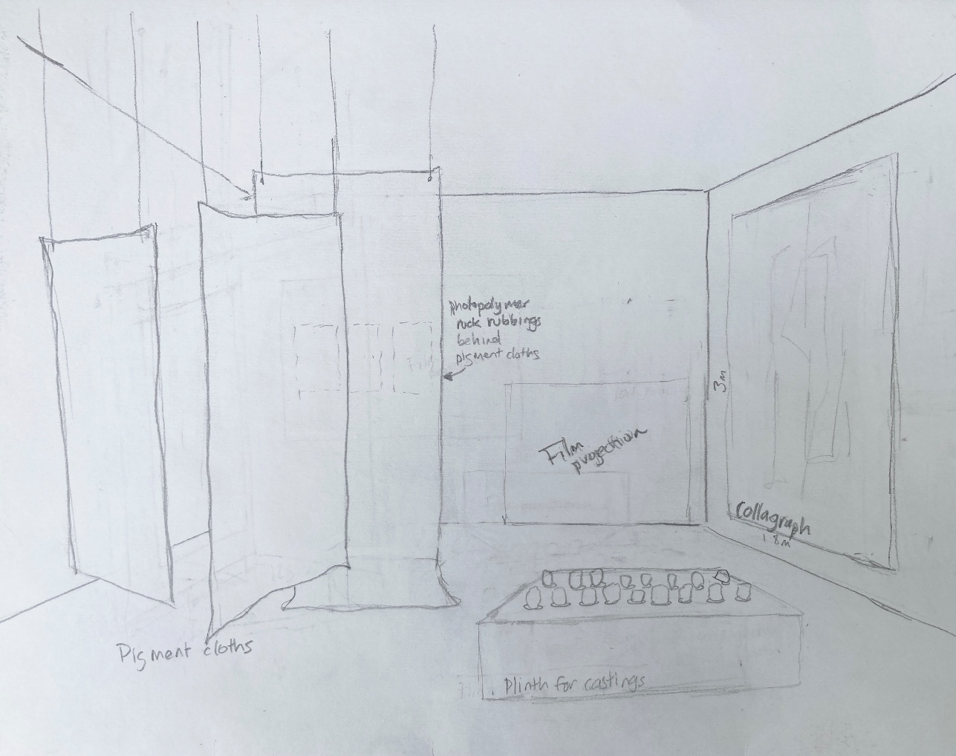

The large pigment cloth hangings will be away from the wall to allow walking around it. The pigment cloths will look something like Photo 2-4, as you have seen before. The pieces will be hung with cord on something like balsa wood or from wire from the ceiling. There may be screenprint on the cloth. The screenprinted form will be something like the rock formation/shadow of a figure seen in Photo 5.
Photo 2-4: Pigment cloths (maybe with screenprint), largest size approx. 240cm x 125cm, smallest 90x100cm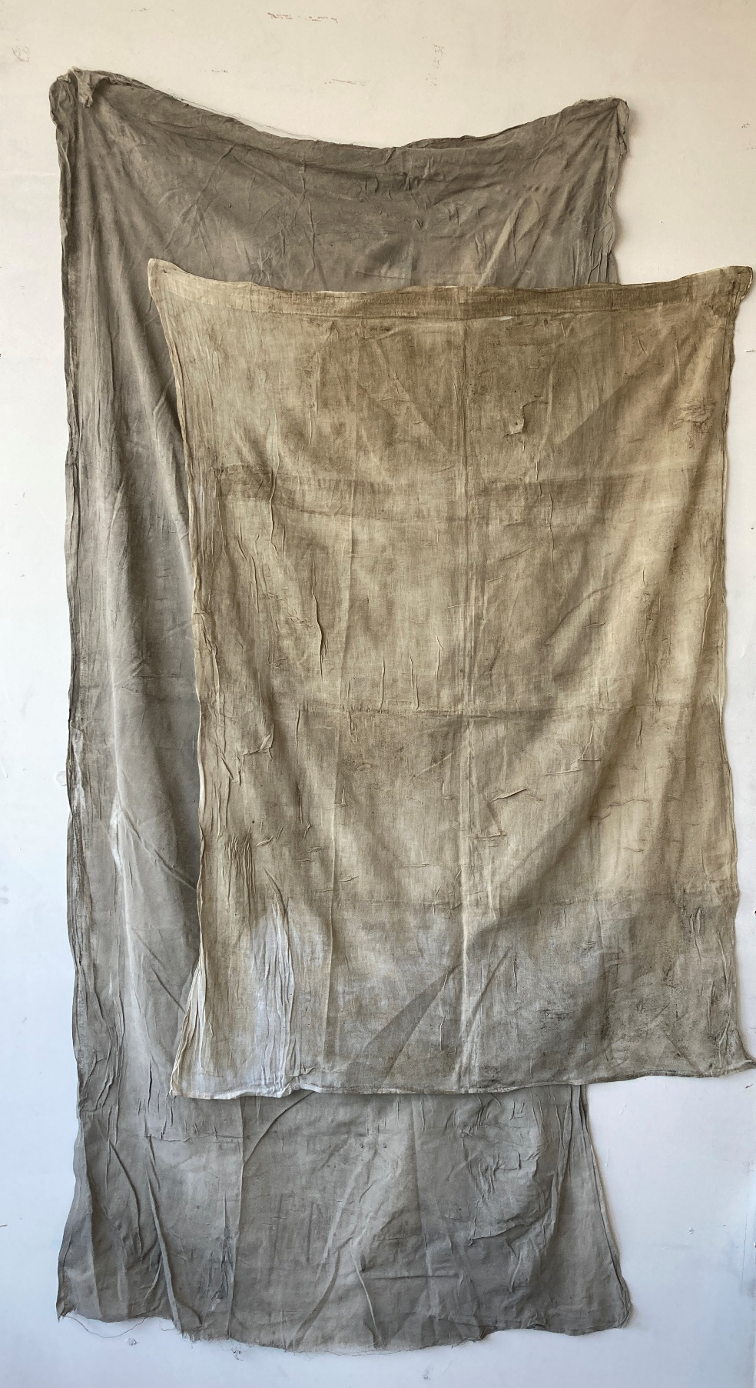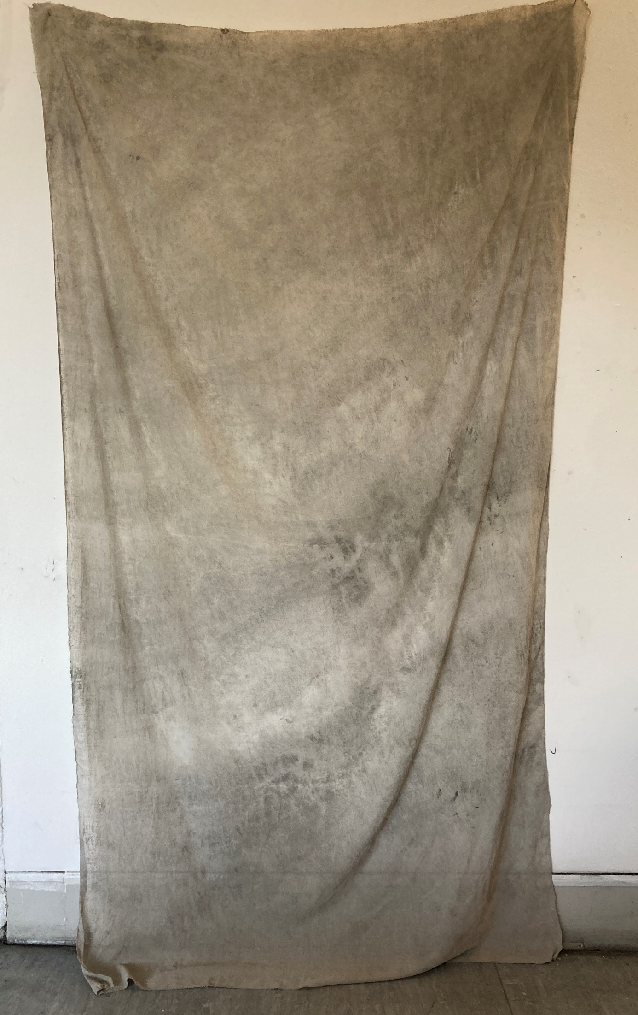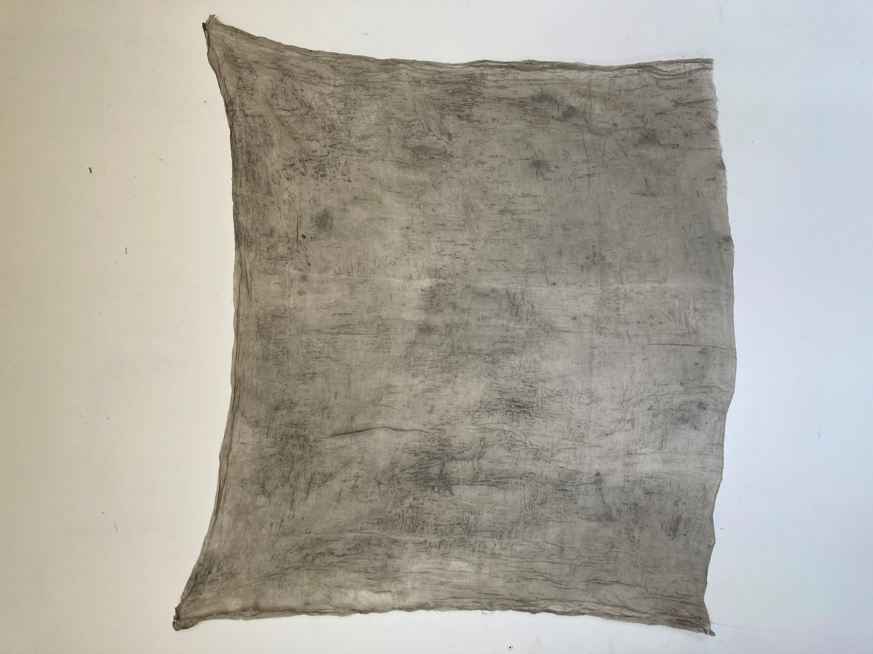
Photo 5: Rock formation and crevices with figure, size to fit on pigment cloths
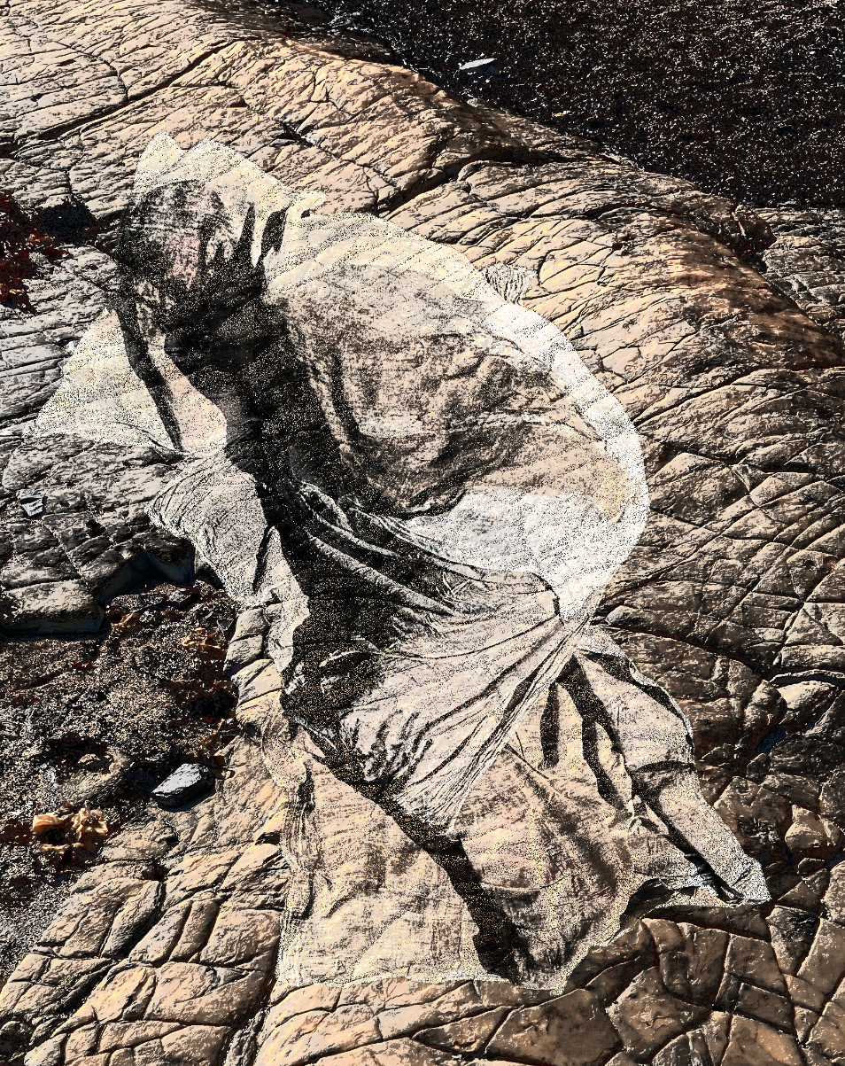
Photos 6 and 7: Plaster castings, actual size of each one approx. 8cm x 10cm
Plaster castings (approx. 12) of imprints from rocks/my hand will be held/displayed in the space. The actual display is to be decided – it might be on a plinth or in a bespoke display frame. The sculpture will be fixed onto a plinth that viewers can also walk around. Examples of the castings are shown below.

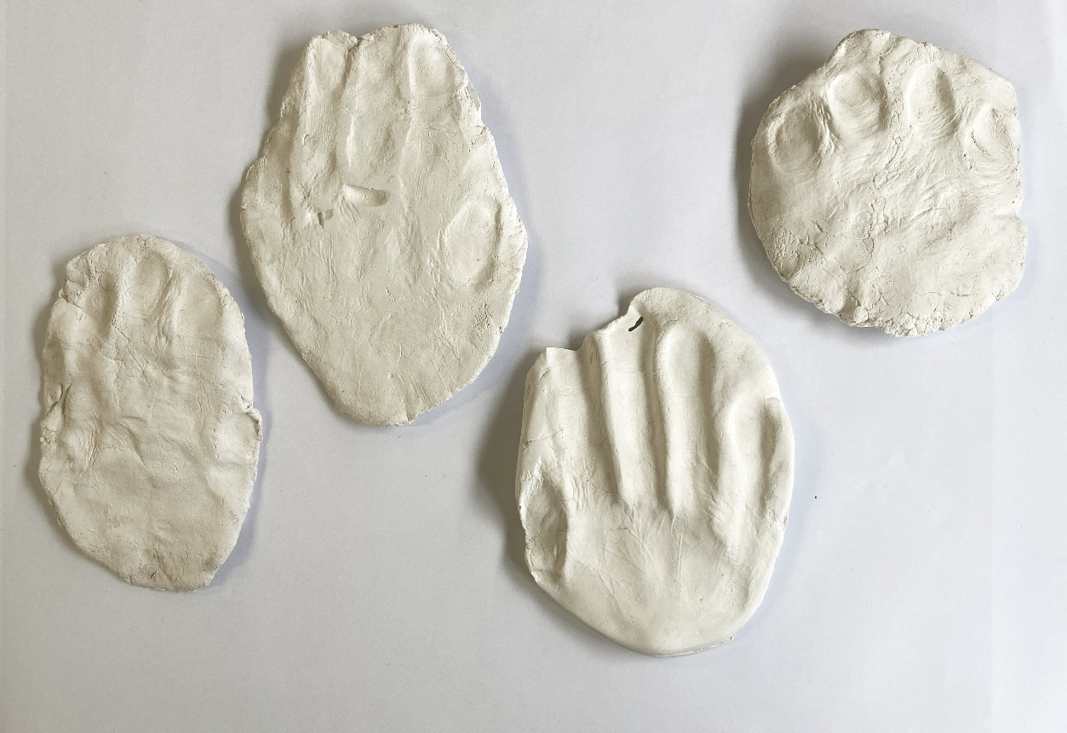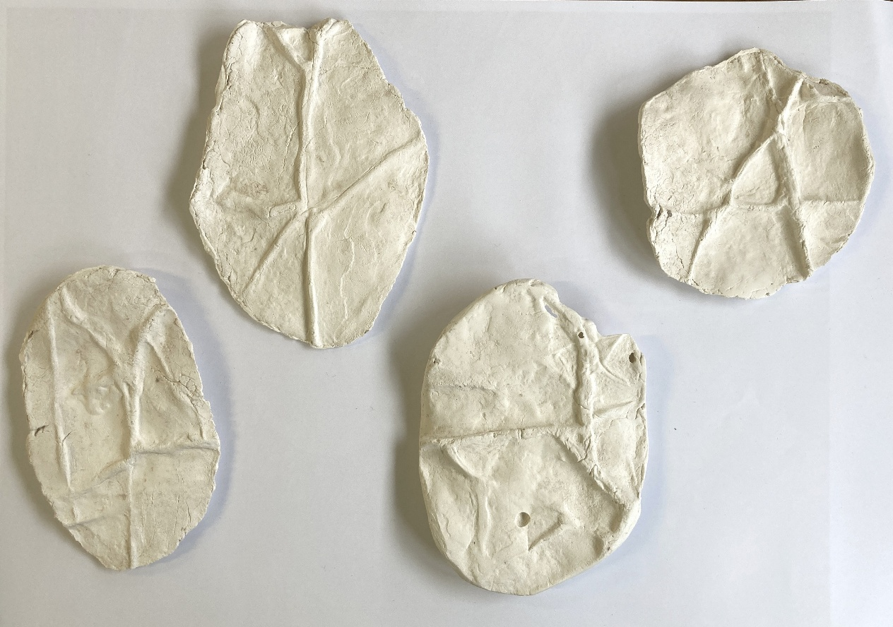

Photos 8, 9, 10: example of large collagraph made up of a series of prints, size approx. 1m on largest side, colours likely to change

A series of large collagraph prints (approx. number to be determined) will be printed on Japanese paper and secured away from the wall using pins and magnets. Some additional paper backing may be necessary to keep the prints secure. The image ‘design’ of these will be different to what is shown below but these give an example of the ‘crevices’ type of image that will be explored.

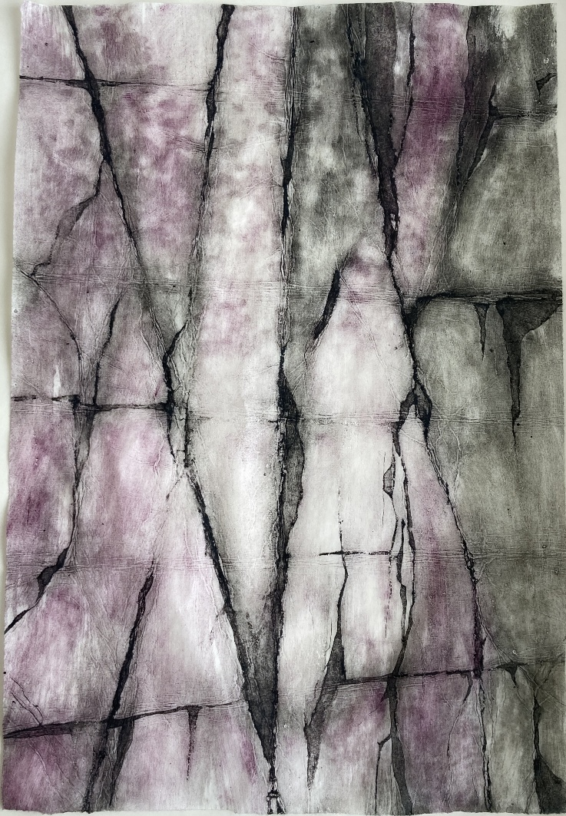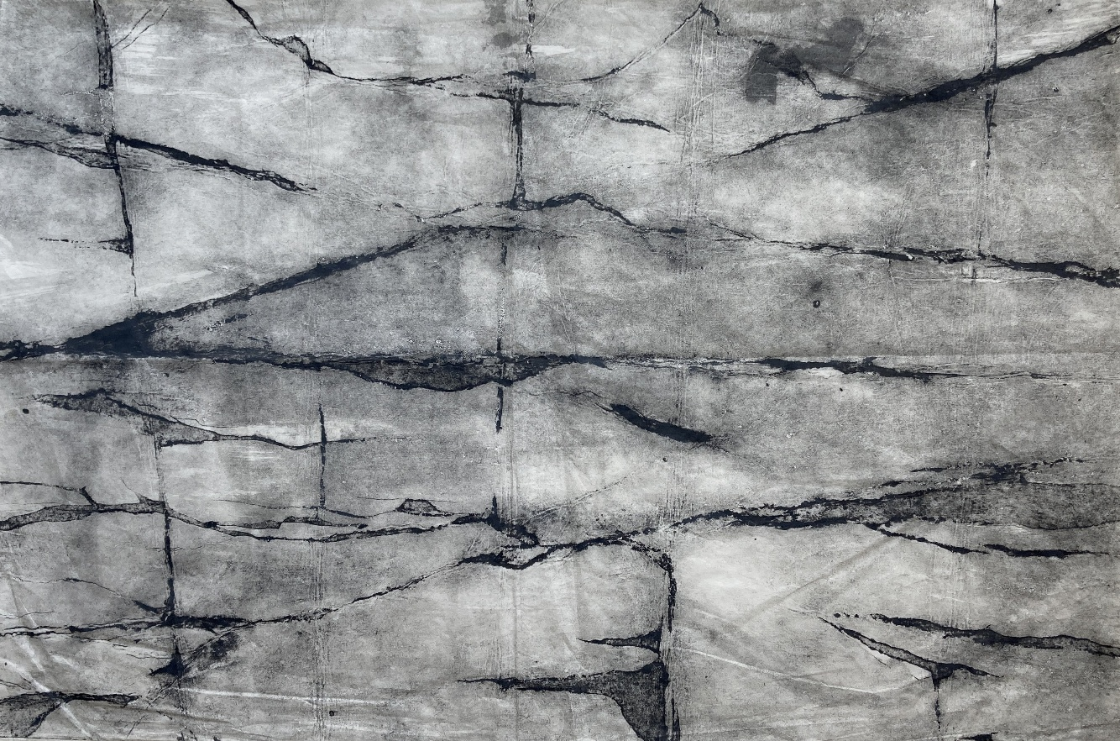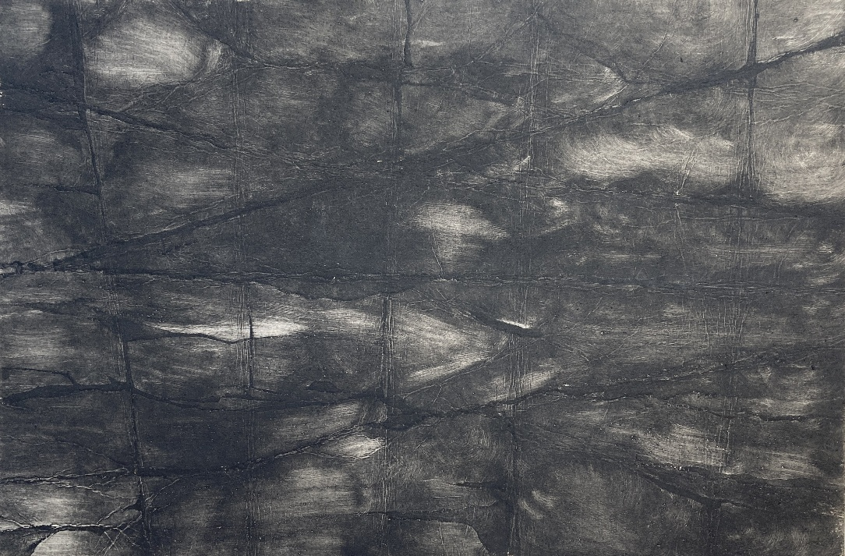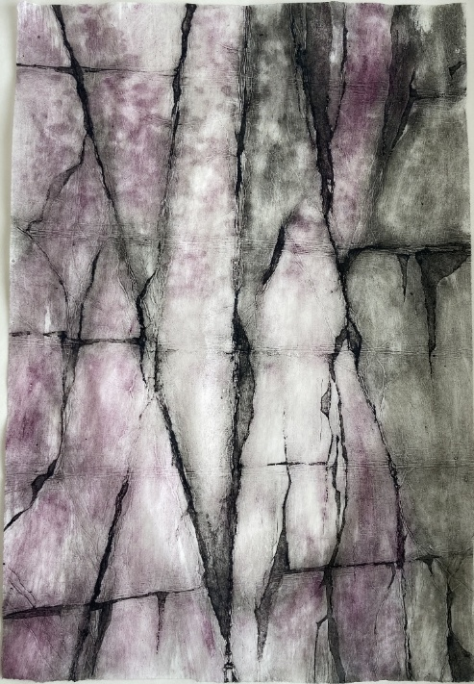

Alongside the large collagraph prints will be a series of 3 photopolymer prints of rock rubbings, these will also be secured with pins and magnets away from the wall.

Photo 11: example of rock rubbing, photopolymer prints, paper size approx. 38x44cm
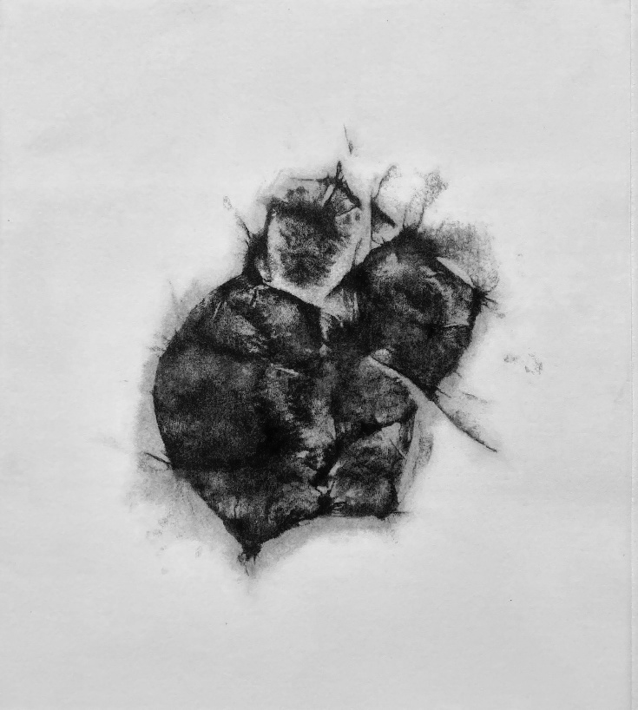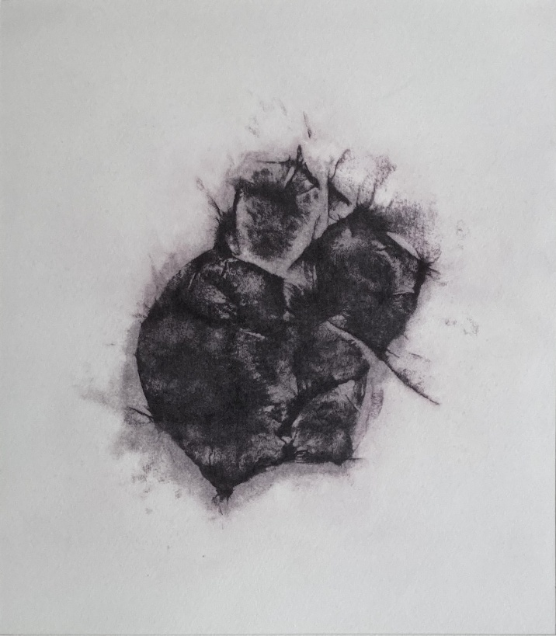

Film and sound

I envisage using film.

The film needs some work – its possible it will be a projection onto the cloth instead of screenprinting the rocks/figure. Or it might be projected onto the plaster castings, or the wall. I need to try these options out.

Film content has not yet been created. It will related to the interaction of rocks and water at the coast an example in the following clips:

https://vimeo.com/manage/1082135485/general

Do you have any other specific requests?
e.g power supply, a corner, floor space, a darkened area? Does the work have the potential to ‘interfere’ with other exhibits (sound etc)?

I would like a corner space that is large enough for people to walk around my pieces and get an immersive effect.
I will need a plinth – size to be decided
I will need a socket for projector (probably projected low from the floor)
I do not envisage the need for a completely dark space

What are the health and safety considerations?

Risk Assessment information: This is a public show in a professional gallery space so it’s imperative that you inform us of potential issues regarding your proposed work and that everyone completes a Risk Assessment.
Risk assessments cover anticipated potential dangers associated with installing artwork, from time lost through breakages and repairs, to accidents and potential public risk during the exhibition.

Risk assessments forms are available on Moodle to download. Please complete and include with your proposal.

Common risks include potentially hazardous materials, handling objects over 25kg, exceptionally large or long work, installing with ladders, suspended work above head height, sharp edges, trip hazards, exposed moving parts, self-made or repurposed powered electrical components, unbalanced or unsecure objects, the inclusion of water, flammable liquids, airborne chemicals, solvents, any preserved, unrefrigerated or decomposing organic matter: insects, animal or human. If you are unsure, include the details.

If you need to be on-site to install you must also complete a UAL Risk Assessment Form prior to installation and the risk assessment must be signed off by a tutor with all safety issues resolved before installation.

Materials: describe any potential hazardous materials. If in doubt about hazardous materials or processes, see a technician or tutor for advice:

Use the space provided here to list hazardous materials:
Risks include use of ladders for installation of work and projectors, large works hanging from the ceiling (which will not be heavy), vulnerable sculpture installation on plinth – will need enough room to walk around to stay safe

There are no hazardous materials

Installation methodology: describe here BRIEFLY how you anticipate we will need to install the work and include any specific assistance or method needed e.g. working at height or with large scale work. For example:
- 2d work: how will the work hang and what tools do we need? Will the work be framed?
- 3d work: how will the work be installed? What tools do we need? Do you anticipate we will need a ladder?
- Projection/monitors/sound: do you need to make plinths, brackets for mounting? Cable covers for power Cables? Test sound levels in an empty space? Explore different projection sizes? Ensure compatibility/availability of hardware or software and technical advice?
- Power outlets: If relevant, state the number of power outlets and plugs will you require? Have you had all electrical equipment PAT tested?

Use the space provided here to describe the installation method:
I will need equipment (ladder, possibly drill, fixings) to hang work from ceiling – possibly fishing wire or cord
I will need hammers/pins/magnets/cord to hang my prints
I will need a projector and socket nearby to power
I will need to have/make a plinth and secure the sculpture to the plinth – method and material to be determined
Ethical:

If you foresee any ethical issues involved with the work that are not listed in the risk assessment, please state them here:

none

